**Lab9: Image Filters, Part II**

Mingqin Dai

**I. Motivation**

We are doing this lab to find the “best” reconstruction of images that have been degraded according to some criterion, based on quantitative knowledge of the degradation, the image and of the noise. Compare to previous labs which also reconstructed degraded images based on image enhancement, the approaches that discussed in this lab is more mathematical and it is possible to obtain high-quality reconstruction of the degraded images. The methods discussed in this lab is used for image restoration, solving image processing problems including image corrupted by noise with known statistics, motion blur, or photographs taken by out-of-focus camera. (Example problems)

**II. Method**

***Part A. Wiener Filtering (With Zero Additive Noise)***

The degradation of an image can be modeled as a blur function and additive noise. In this part, we apply a low pass blurring filter to the original image with zero additive noise. One method of solving this problem is filtering the degraded image with the so-called Wiener filter in order to get the restored image. The coefficients of Wiener filter are chosen so as to minimize MSE between the original image and the restored image. In this lab, we find the filter by first finding the optimal Wiener filter along rows and columns, then multiplying these filters to get the optimal Wiener filter for reconstruction of the image.

The results in part A are as follows.

*a. Frequency response after row filtering and column filtering*

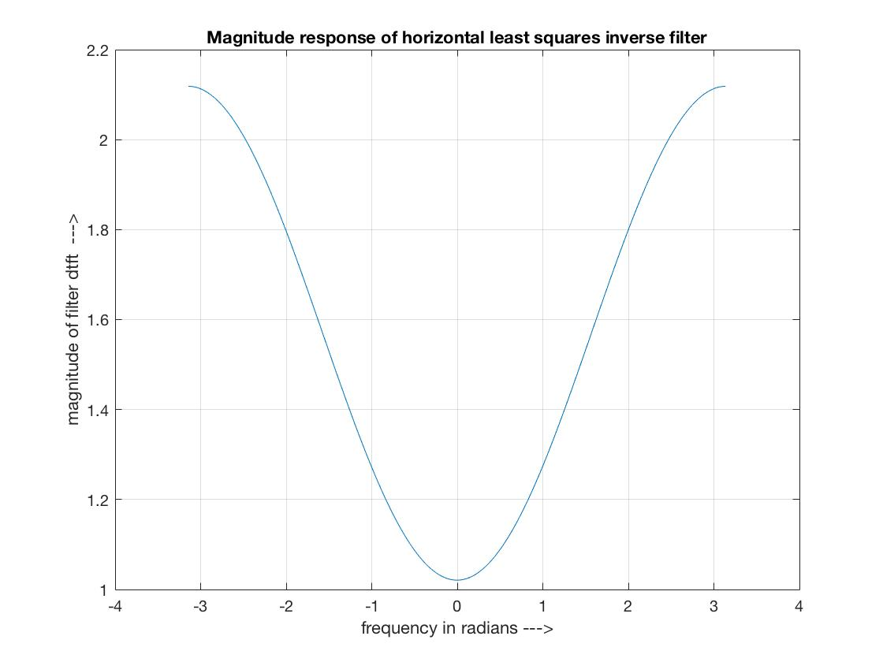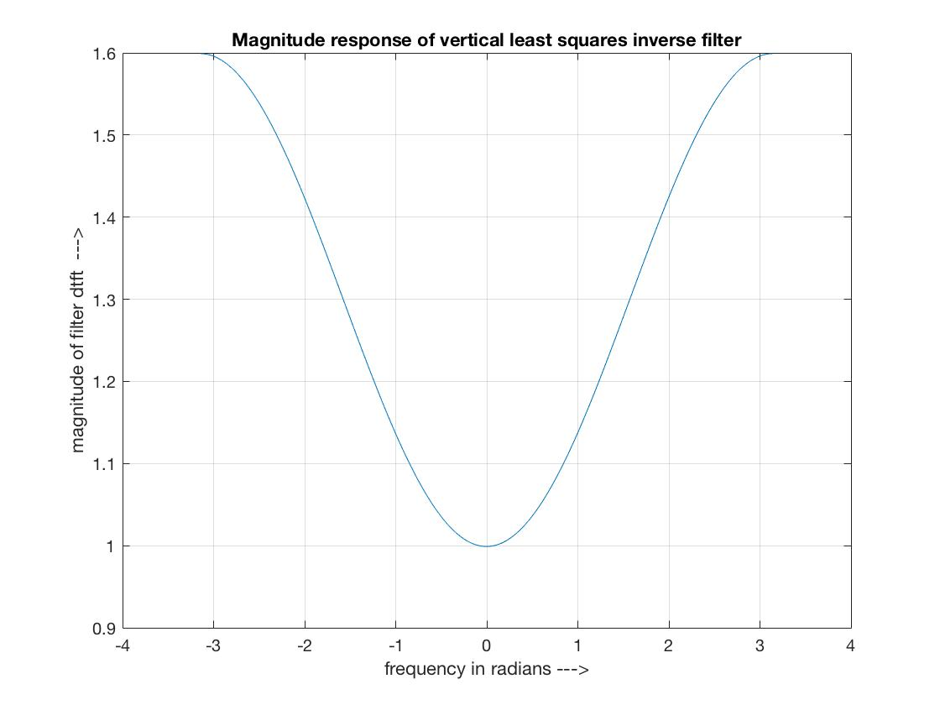

*Horizontal least square inverse filter*  *Vertical least square inverse filter*

The Horizontal and Vertical least square inverse filters are both high pass filters

*b. Frequency response of least square inverse filter*

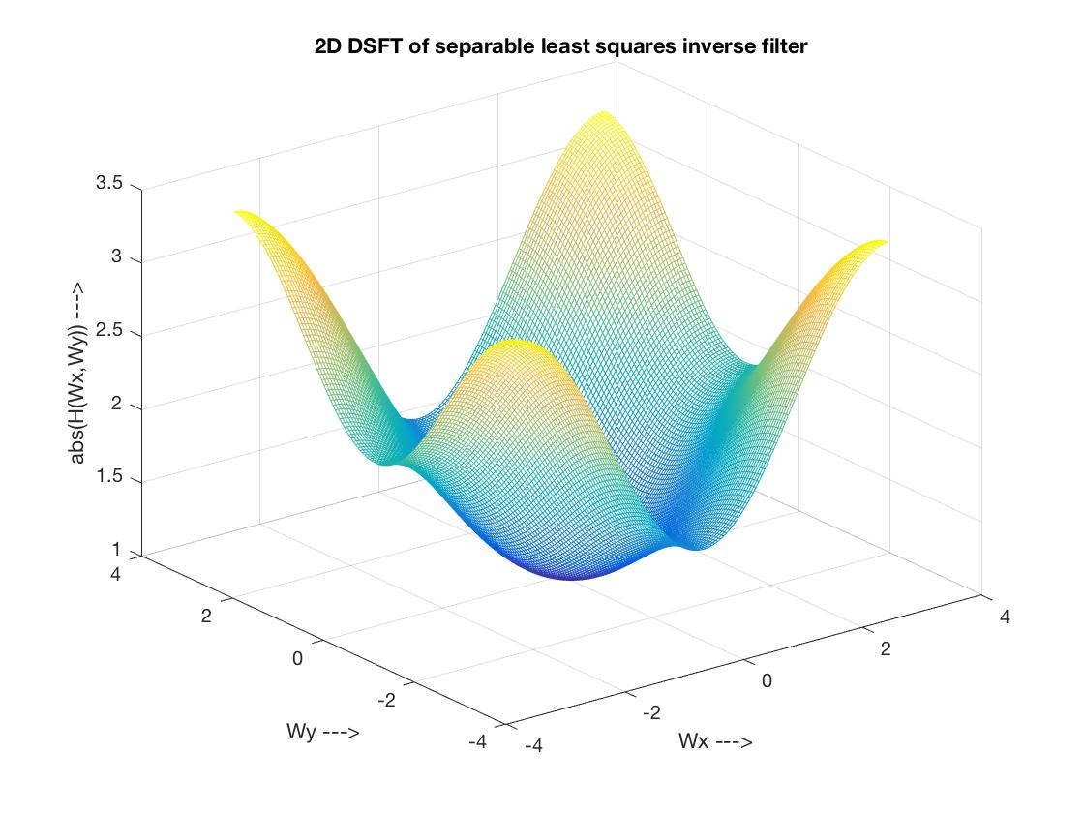

The least square inverse filter is a 2D high pass filter. And it is actually the inverse filter of the lowpass blurring filter.

*c. Filter coefficients*

Filter coefficients for horizontal least square invers filter: $\left[\begin{matrix}-0.2748 & 1.5697 & -0.2740\end{matrix}\right]$.

Filter coefficients for vertical least square invers filter: ${\left[\begin{matrix}-0.1497 & 1.2990 & -0.1503\end{matrix}\right]}^{T}$

Filter coefficients for 2D least squares inverse filter: $\left[\begin{matrix}0.0411 & -0.2350 & 0.0410 \\ -0.3570 & 2.0390 & -0.3560 \\ 0.0413 & -0.2359 & 0.0412\end{matrix}\right]$

*D. MSEs*

MSE after applying horizontal least square inverse filter: $e_{h}=3.1375$.

MSE after applying vertical least square inverse filter: $e_{v}=0.7419$.

MSE after applying 2D optimal filter directly onto the blurred image*: $e= 0.9778$*

***Part B. Wiener Filtering***

The degradation of an image can be modeled as a blur function and additive noise. In this part, we apply a low pass blurring filter to the original image with low and high additive noise by changing the standard deviation of the Gaussian noise. There are three section in the part. First, we apply the 3x3 Wiener filter from part A directly to the degrading image. Second, we find the Wiener filter for reconstruction of the original image corresponding to low and high noise case respectively following exactly the same procedure in part A. Third, we applying MATLAb’s wiener2() function to degrading image and compare the result images to the images we got in the previous section.

***Section 1. Applying 3x3 Wiener filter from part A directly to degrading image.***

*a. Frequency response and Filter coefficients.*

Since we apply 3x3 wiener filter from part A, the frequency response and filter coefficients of horizontal, vertical least square invers filter are exactly the same with previous part, so as the 2D least squares invers filter.

*b. MSEs*

*1. $σ=5$*

MSE after applying horizontal least square inverse filter: $e_{h}=68.6711$.

MSE after applying vertical least square inverse filter:

MSE after applying 2D optimal filter directly onto the blurred image*:*

All three MSEs are larger than the MSE between the degraded image and the original image which is 42.9824.

*2.*

MSE after applying horizontal least square inverse filter: .

MSE after applying vertical least square inverse filter:

MSE after applying 2D optimal filter directly onto the blurred image*: $4.0766×{10}^{3}$*

All three MSEs are larger than the MSE between the degraded image and the original image which is 916.3773.

*c. Output images and original image*

*Original Image $σ=5$ Restored Image*

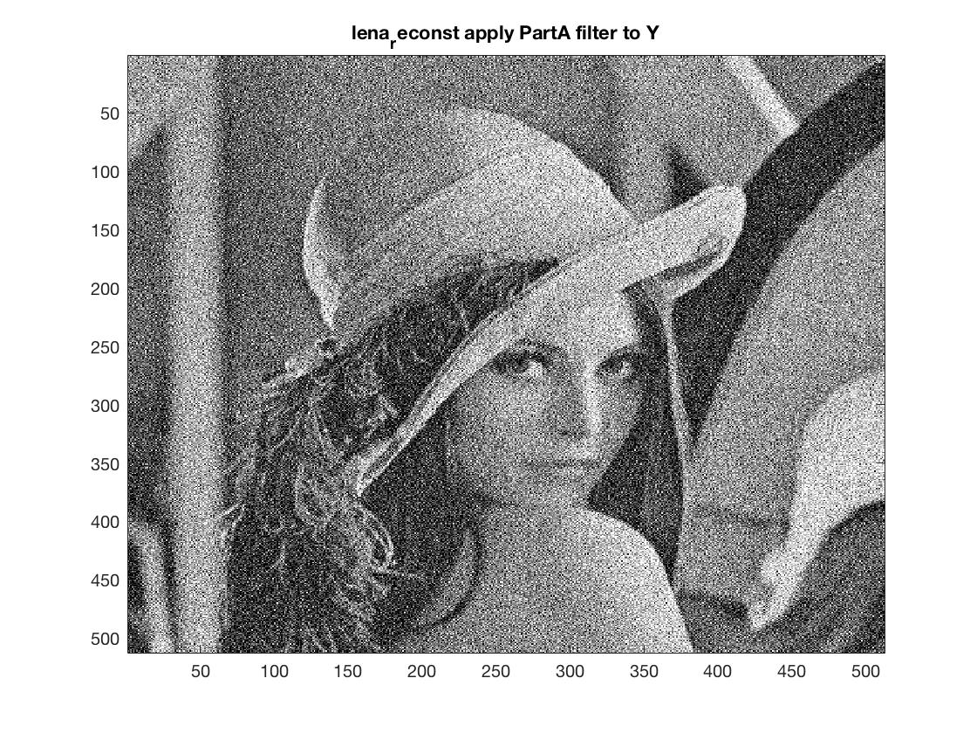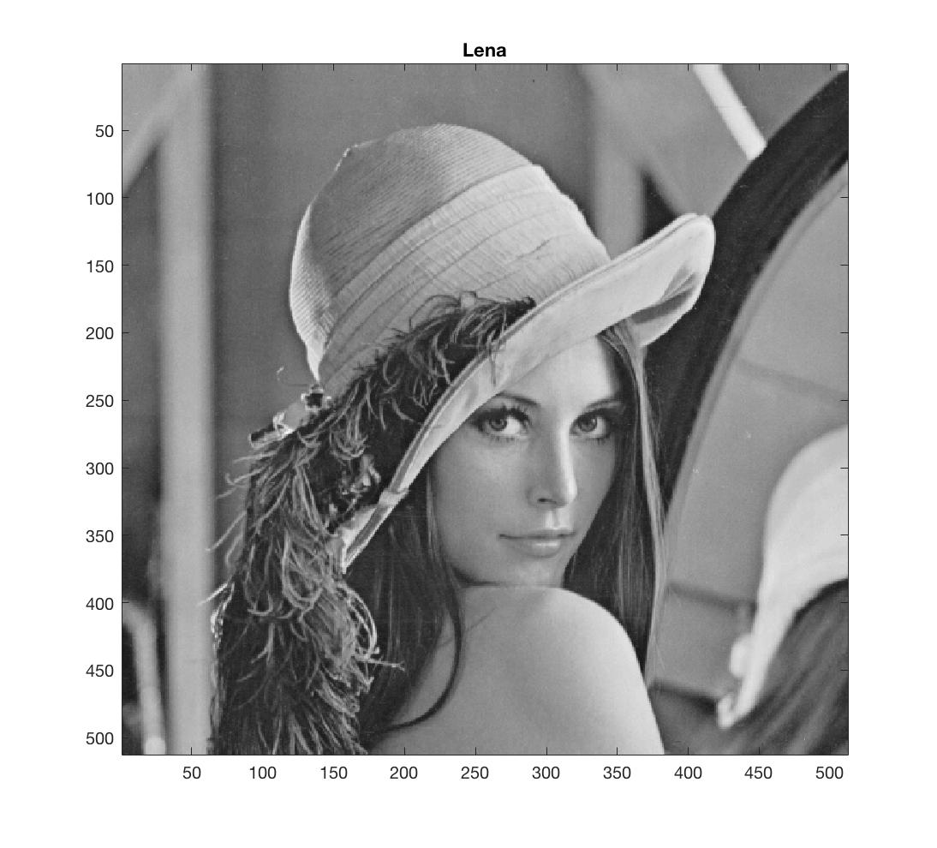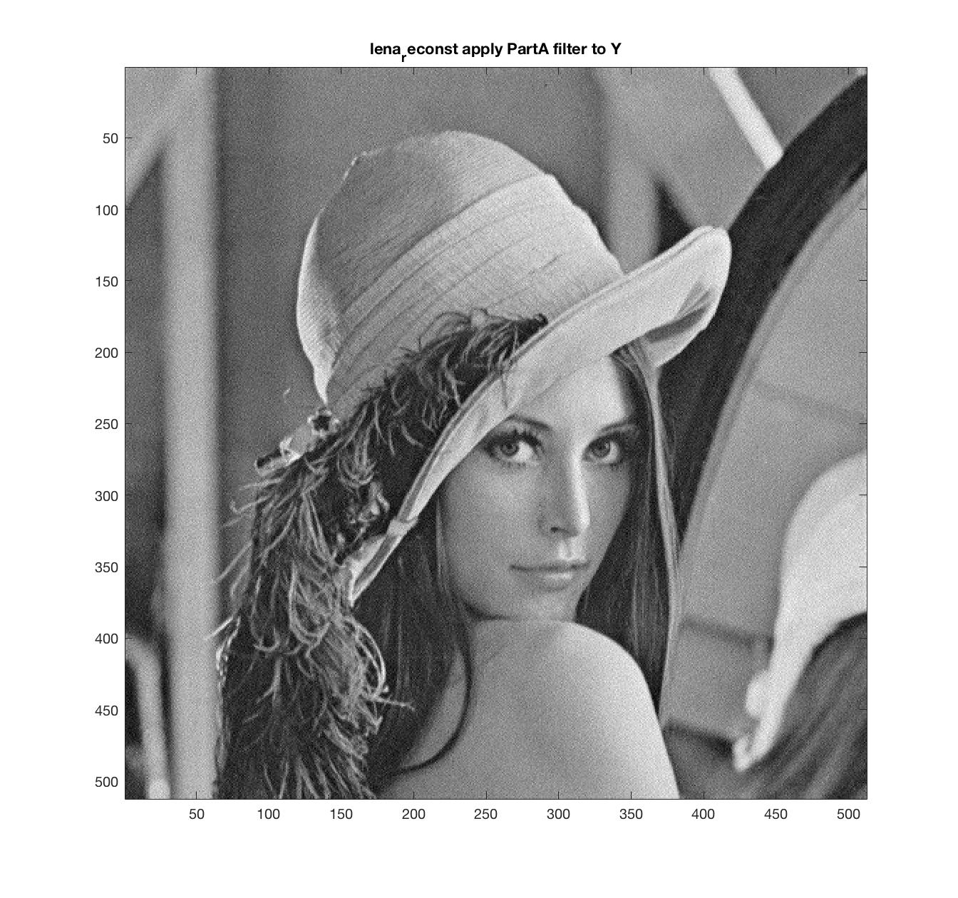

*Original Image $σ=30$ Restored Image*

Overall, comparing the output images to the original image, the restored image has variations in intensity of pixels. In $σ=5$ case*,* this appearance is less apparent, though we can still recognize comparing with the original image. In $σ=30$ case, we can apparently recognize this effect.

We can see it in the image that it causes variations in intensity of pixels in the original image drawn from a Gaussian normal distribution. The reason is that the Wiener filter we found in Part A is a high pass filter, and it can be extremely large at high frequencies. This cause the tremendous amplification of the high-frequency components of the noise. Thus this filter is subject to artifact, causing the effect we recognized. ***(How does the output image look? Why?)***

***Section 2. Optimal Wiener filter for reconstruction.***

*a. Frequency response after row filtering and column filtering*

*1.*

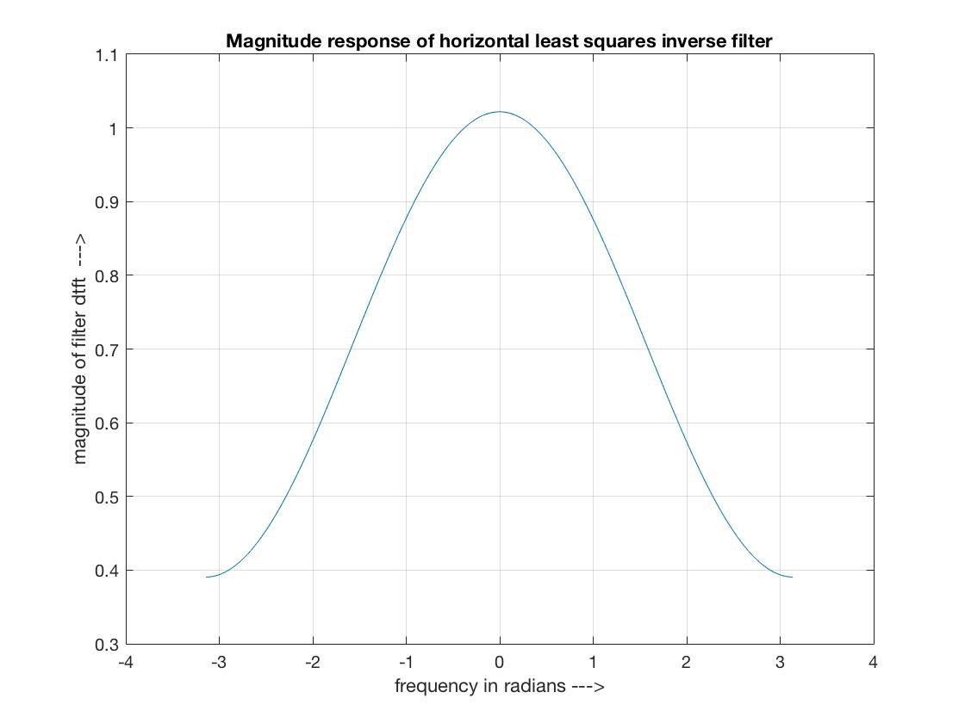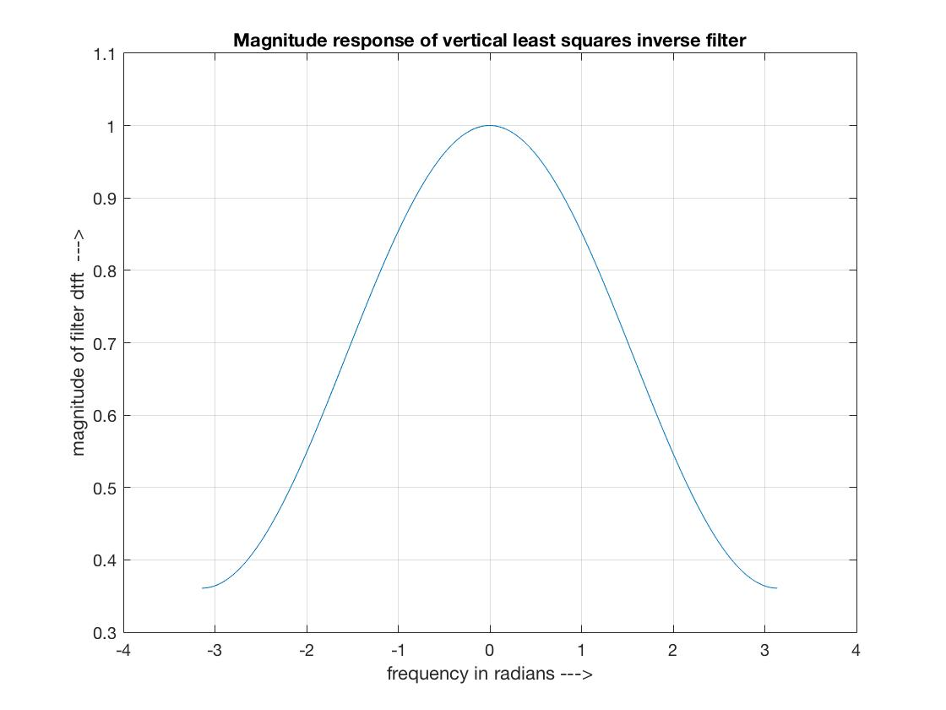

*Horizontal least square inverse filter*  *Vertical least square inverse filter*

*2.*

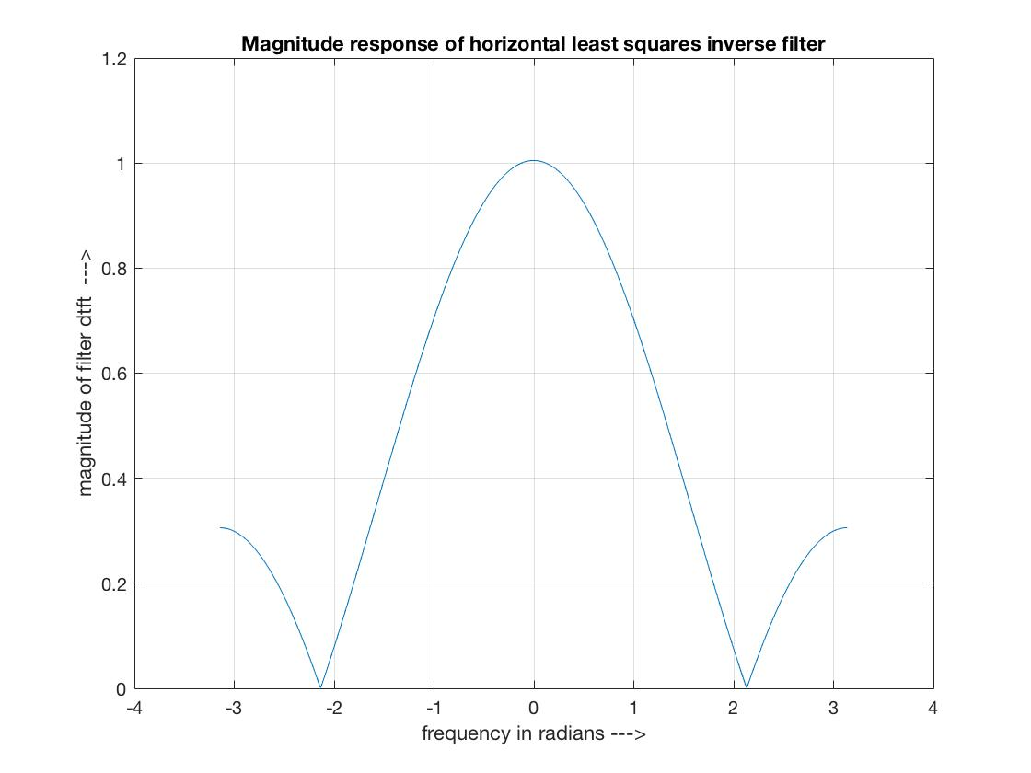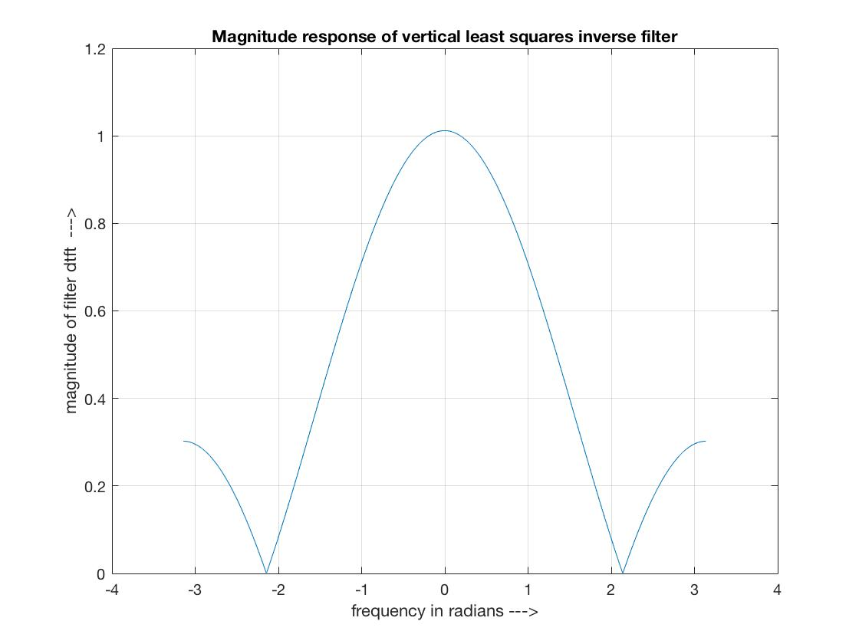

*Horizontal least square inverse filter*  *Vertical least square inverse filter*

The Horizontal and vertical least square invers filters in low and high noise case are both low pass filters

*b. Frequency response of least square inverse filter*

*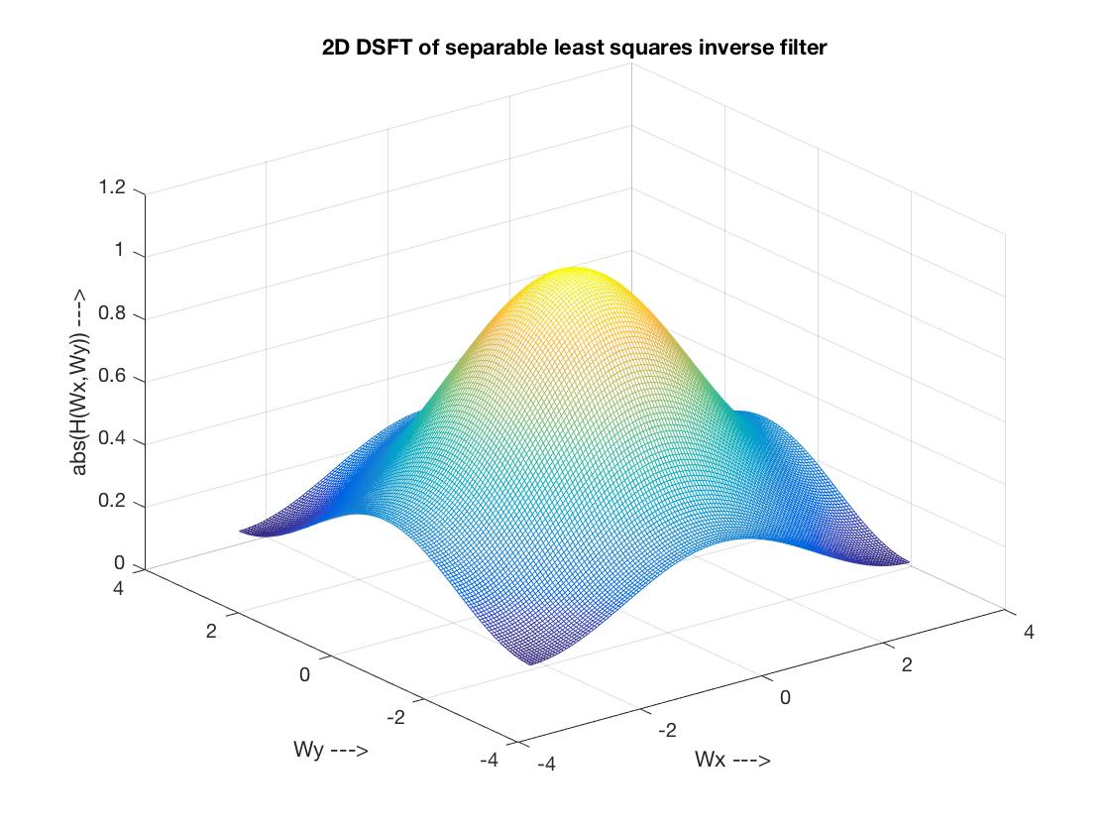1. $σ=5$*

*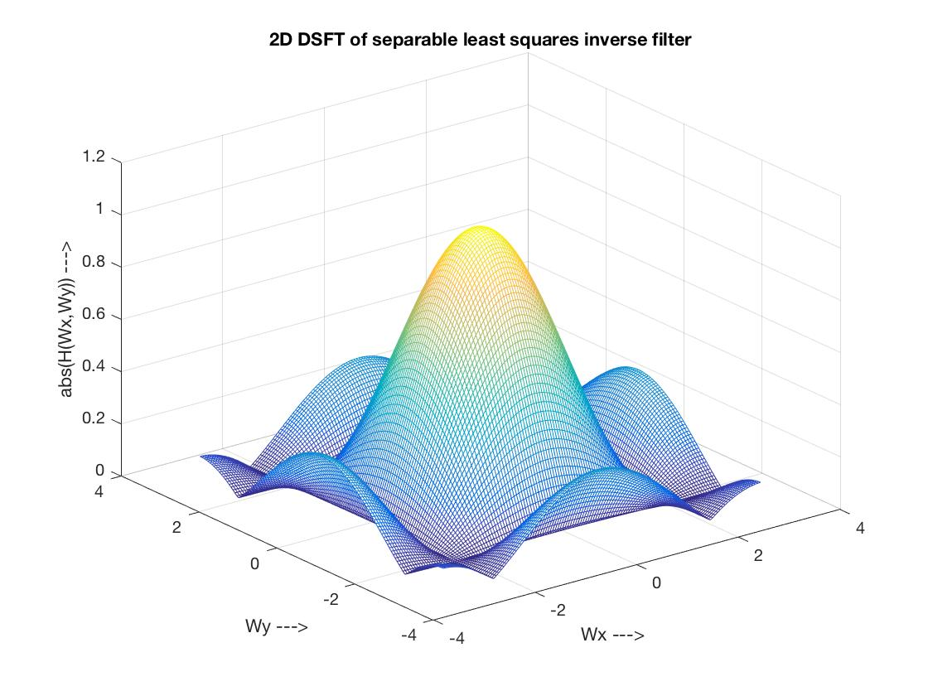2. $σ=30$*

The least square inverse filter in both cases are 2D low pass filters.

*c. Filter coefficients*

*1. $σ=5$*

Filter coefficients for horizontal least square invers filter: $\left[\begin{matrix}0.1569 & 0.7070 & 0.1580\end{matrix}\right]$.

Filter coefficients for vertical least square invers filter: ${\left[\begin{matrix}0.1588 & 0.6827 & 0.1586\end{matrix}\right]}^{T}$

Filter coefficients for 2D least squares inverse filter: $\left[\begin{matrix}0.0249 & 0.1123 & 0.0251 \\ 0.1071 & 0.4827 & 0.1079 \\ 0.0249 & 0.1121 & 0.0251\end{matrix}\right]$

*2. $σ=30$*

Filter coefficients for horizontal least square invers filter: $\left[\begin{matrix}0.3282 & 0.3500 & 0.3274\end{matrix}\right]$.

Filter coefficients for vertical least square invers filter: ${\left[\begin{matrix}0.3301 & 0.3541 & 0.3276\end{matrix}\right]}^{T}$

Filter coefficients for 2D least squares inverse filter: $\left[\begin{matrix}0.1083 & 0.1155 & 0.1081 \\ 0.1162 & 0.1239 & 0.1159 \\ 0.1075 & 0.1147 & 0.1073\end{matrix}\right]$

*d. MSEs*

*1. $σ=5$*

MSE after applying horizontal least square inverse filter: $e_{h}=28.5305$.

MSE after applying vertical least square inverse filter:

MSE after applying 2D optimal filter directly onto the blurred image*:*

All three MSEs are larger than the MSE between the degraded image and the original image which is 42.9824.

*2.*

MSE after applying horizontal least square inverse filter: .

MSE after applying vertical least square inverse filter: .

MSE after applying 2D optimal filter directly onto the blurred image*: $e= 154.4721$*

All three MSEs are larger than the MSE between the degraded image and the original image which is 916.3773.

Overall, the MSEs in both low and high noise cases are relatively small compared with the MSEs in previous section. This effect is more apparent in high noise case. And all of the MSEs in both cases are smaller than the MSE between the degraded image and the original image. ***(How does this MSE compare with the MSE from the previous paragraph? )***

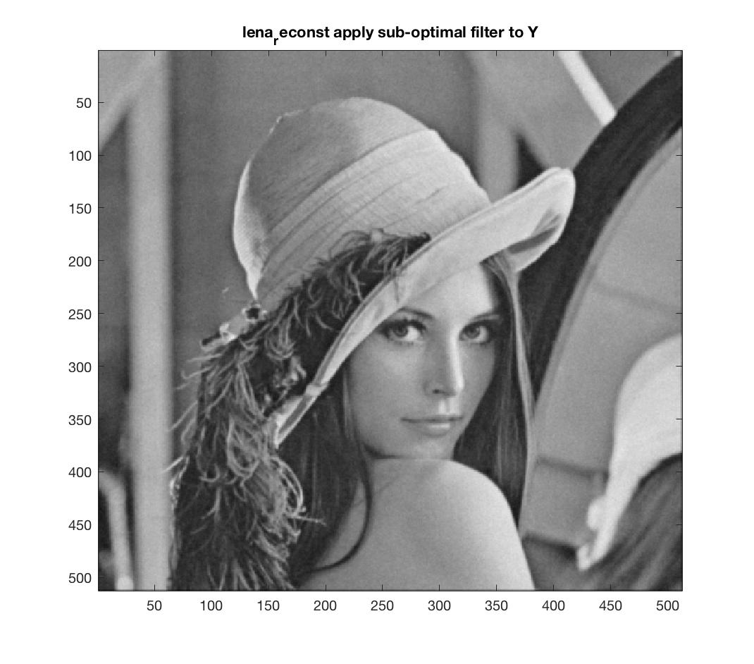 *e. Restored Images and Original Image*

*Original Image $σ=5$ Restored Image*

*Original Image $σ=30$ Restored Image*

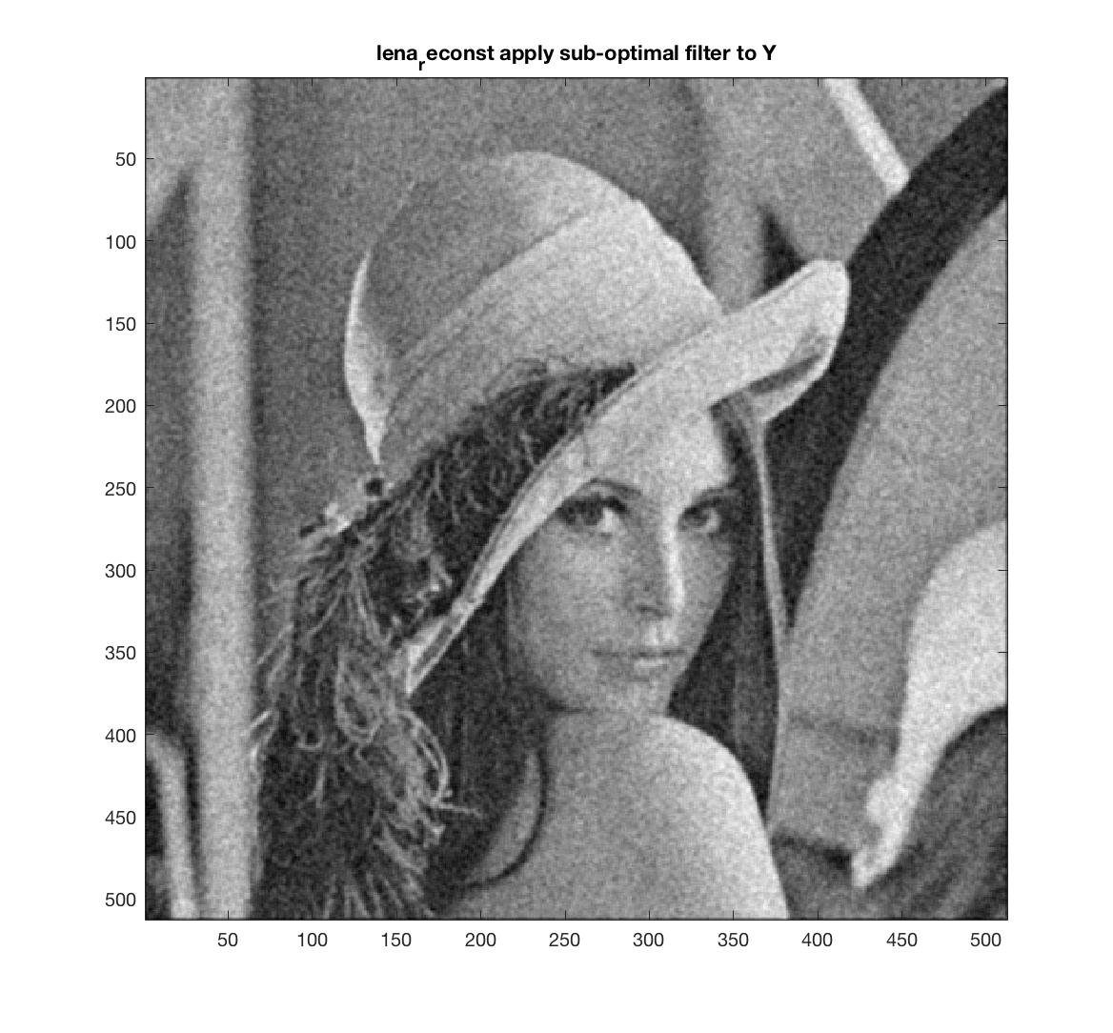

Overall, comparing the output images to the original images, the restored images still has variations in intensity of pixels just like in Section 1, especially for $σ=30$ case, however, these variations is much smoother compared with those in Section1. We can recognize it apparently in comparing $σ=30$ case. And in $σ=5$ case, the variations in intensity could hardly be recognized with this size, the variations could be recognized if we magnify the image in a much larger size. ***(Compare the output to the original image.)***

***Section3. Applying Matlab’s wiener2() function to degrading image.***

*a. MSEs*

*1. $σ=5$*

MSE after applying 3x3 wiener2 function onto the blurred image*: $e=31.4924$* ***.***

MSE after applying 5x5 wiener2 function onto the blurred image*:* ***.***

MSE after applying 7x7 wiener2 function onto the blurred image*:* ***.***

MSE after applying 2D optimal filter directly onto the blurred image (Section 2 Method): $e=32.8154$**.**

MSE of the original image and degraded image: $e=42.6609.$

*2. $σ=30$*

MSE after applying 3x3 wiener2 function onto the blurred image*: $e=198.5148$* ***.***

MSE after applying 5x5 wiener2 function onto the blurred image*:* ***.***

MSE after applying 7x7 wiener2 function onto the blurred image*:* ***.***

MSE after applying 2D optimal filter directly onto the blurred image (Section 2 Method): $e=156.0321$**.**

MSE of the original image and degraded image: $e=919.8248$**.**

*b. Restored Images using Wiener2 function and method in previous section.*

*1.*

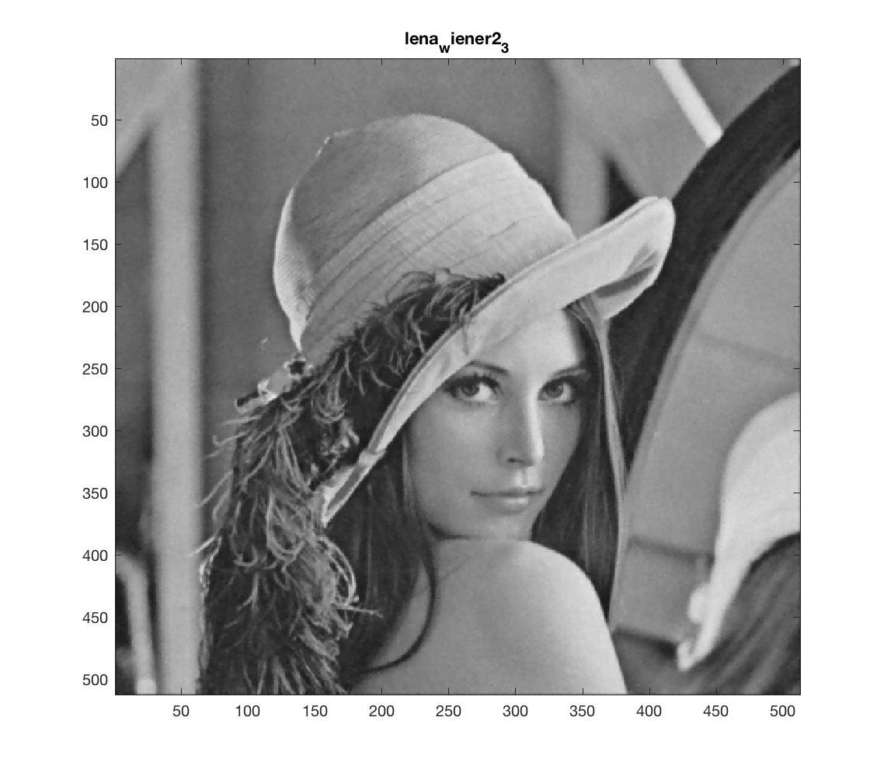

*Restored image in Section 2 $σ=5$ 3x3 Wiener2 function*

$σ=5$*5x5 Wiener2 function $σ=5$* *7x7 Wiener2 function*

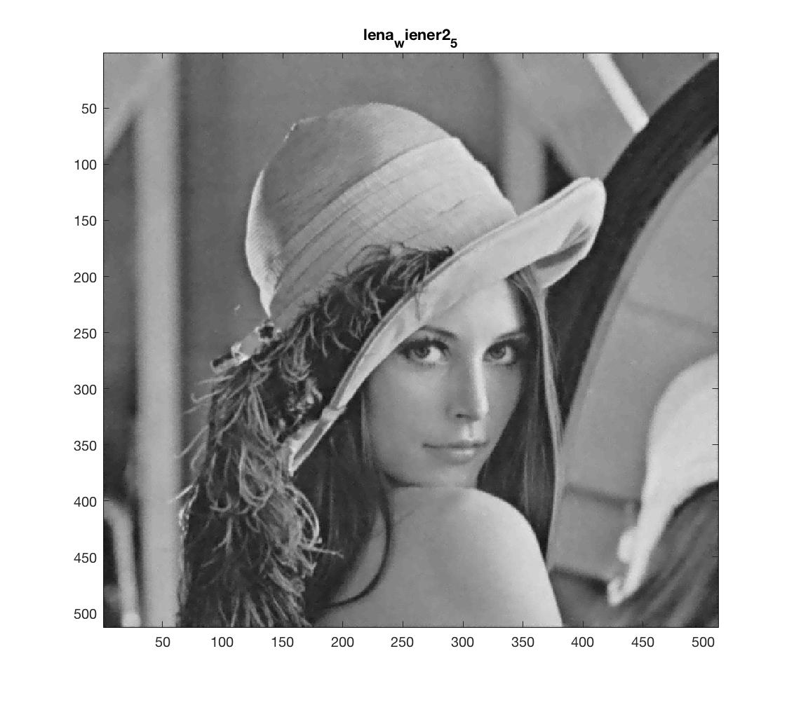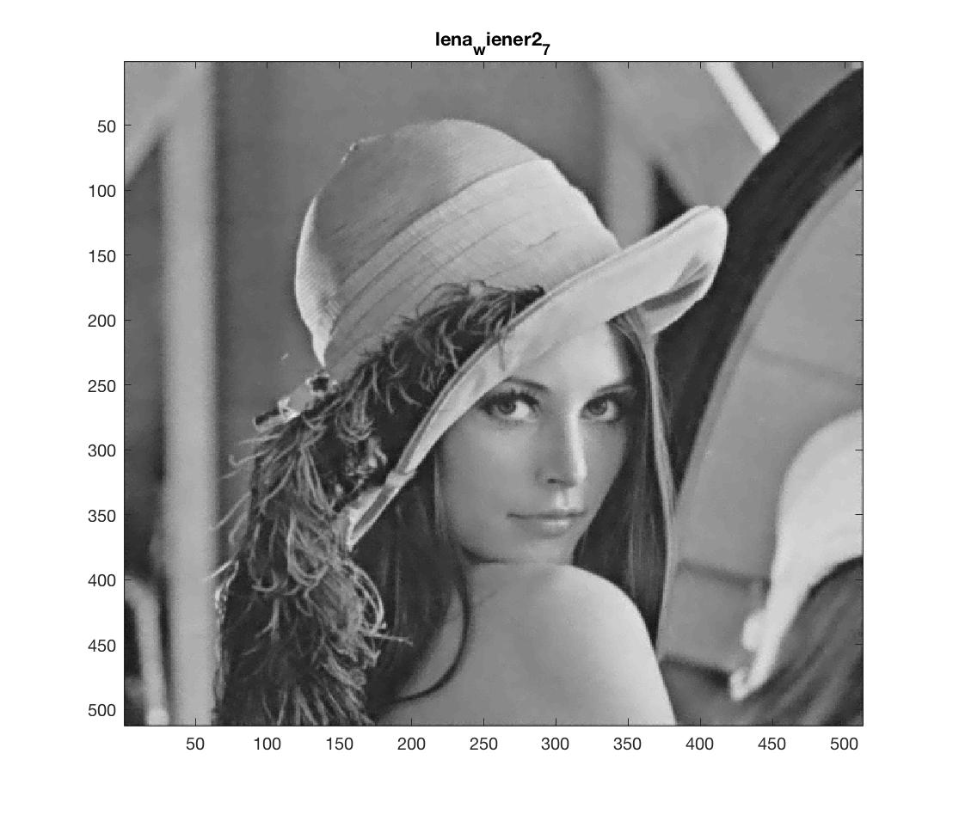

In low noise case, we could hardly tell the difference between the restored image in Section 2 and the restored images using different window sizes Wiener2 function. And we could hardly recognize the artifacts. As the window size increases, the restored image become smoother, which also means become more blur. If we magnify the images, the restored image in section2 is more similar with restored image using 3x3 Wiener2 function. ***(Compare Matlab's Wiener-filtered image to your own, and comment in the lab write-up about the performance of each. Low noise case)***

*2.*

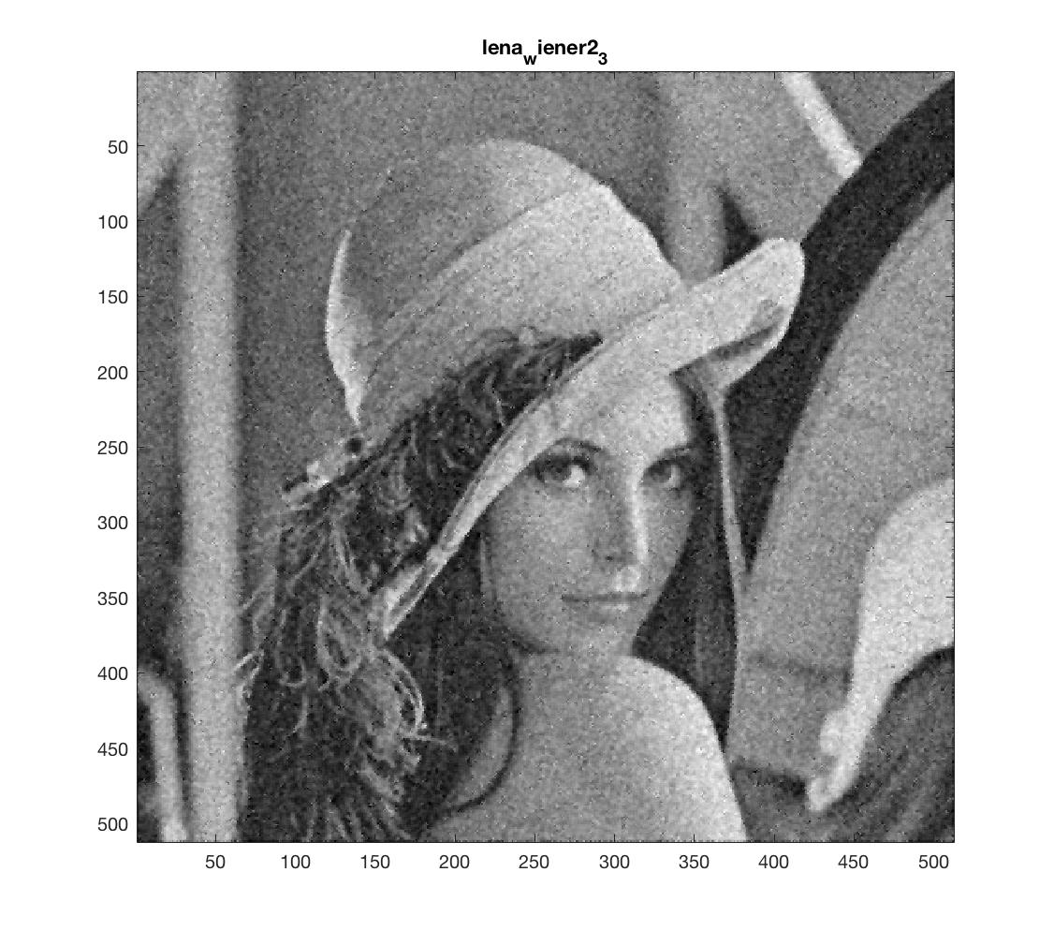

*Restored image in Section 2 $σ=30$ 3x3 Wiener2 function*

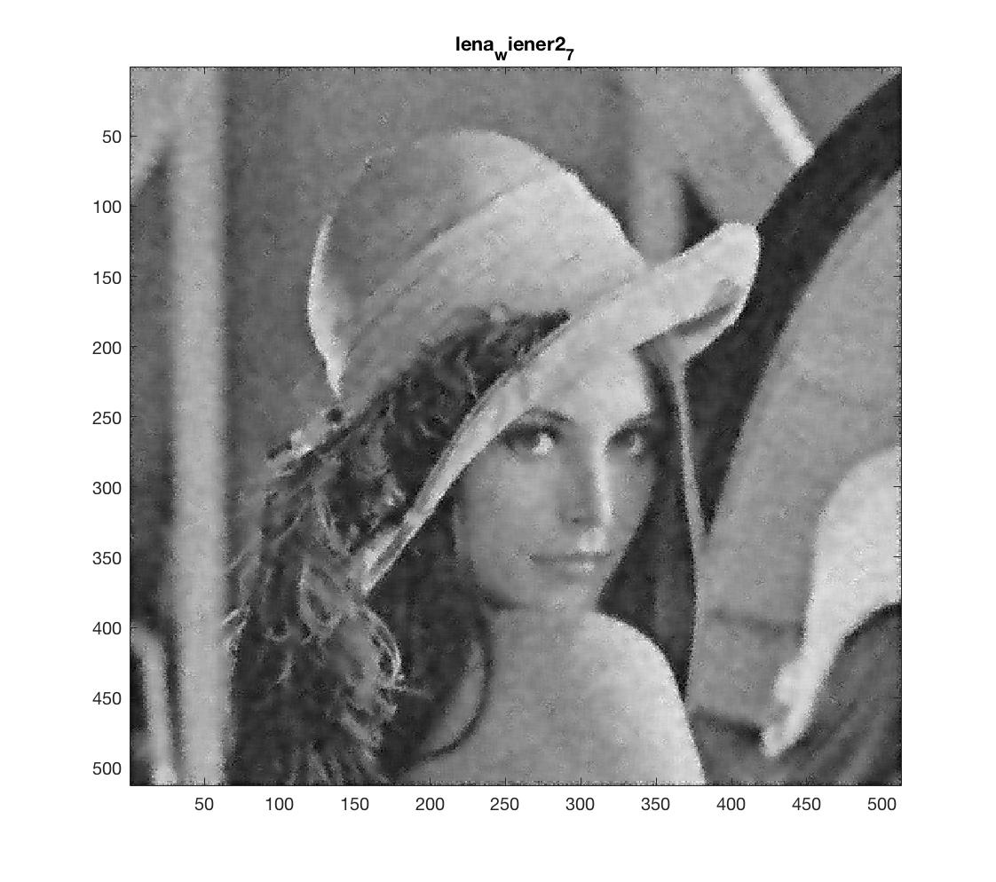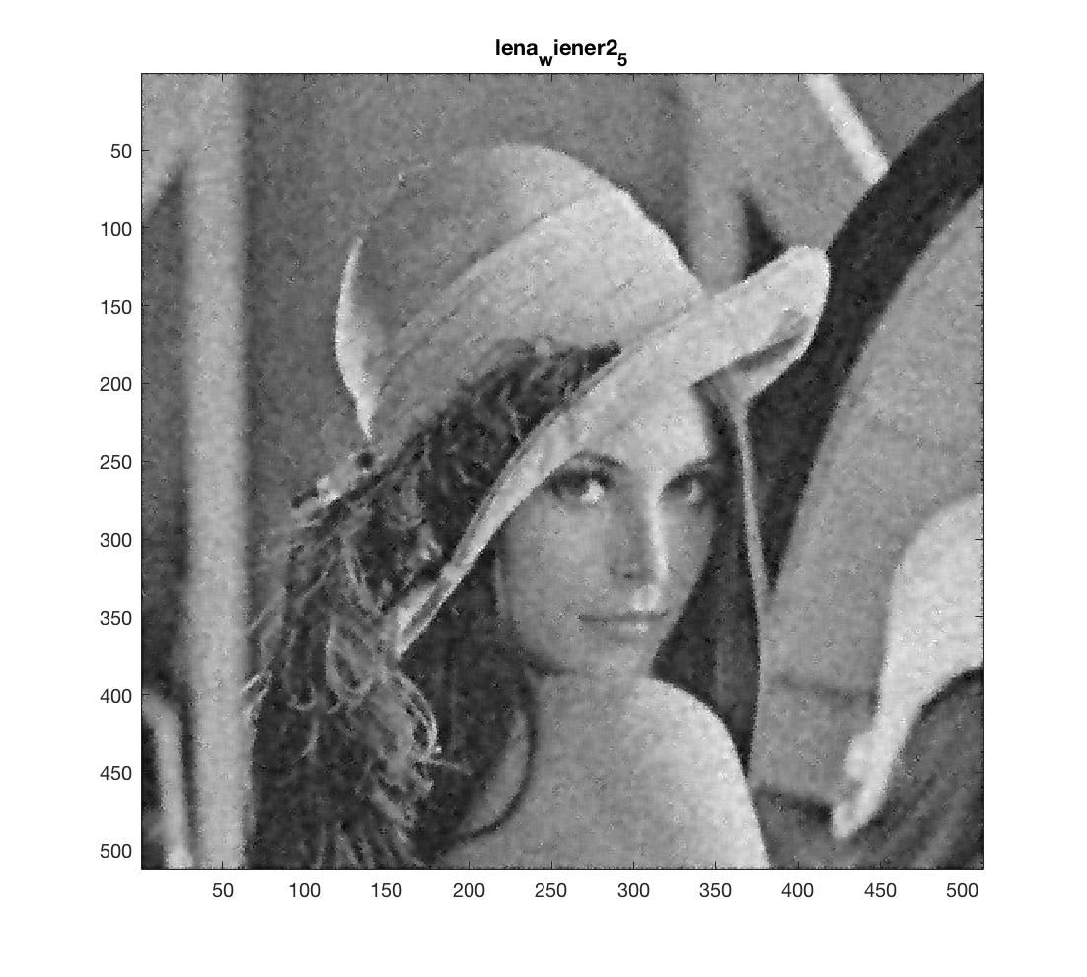

*5x5 Wiener2 function $σ=30$ 7x7 Wiener2 function*

In high noise case, there are apparent difference between the images. The variations of intensity of pixels is more apparent in restored image from Section 2 compared with restored images using 5x5 and 7x7 Wiener2 function, and less apparent in restored image from Section 2 compared with restored images using 3x3 Wiener2 function. And 3x3 Wiener2 function gives clearest image, followed by restored image in Section2, restored image using 5x5 Wiener2 function and 7x7 Wiener2 functions. As the window size increases, the restored image become smoother, which also means the image become more blur and the variations of intensity of pixels become less apparent. For the case using 7x7 window, we get most blur image and least variations of intensity of pixels. Subjectively, the appearance of image from Section 2 is between images using 3x3 and 5x5 Wiener2 function. ***(Compare Matlab's Wiener-filtered image to your own, and comment in the lab write-up about the performance of each High noise case.)***

***Part C. Discussion (Answering Questions)***

Suppose the filter used for reconstructing image has impulse response *g(t)* and frequency response *G(f)*. (Here t and f all refers to vectors). And the blurring filter has impulse response *h(t)* and frequency response *H(f)*. In Part A, the relationship between blurring filter and the resulting Wiener filter is $G\left(f\right)=\frac{1}{H(f)}=H^{-1}(f)$, which means the Wiener filter is the inverse filter of blurring filter. At both high and low noise case, because the degraded images have same degradation model, and the resulting Wiener filter is calculated among same method. The relationship between blurring filter and the resulting Wiener filter is $G\left(f\right)=\frac{H^{*}(f)S_{x}(f)}{{\left|H\left(f\right)\right|}^{2}S_{x}\left(f\right)+{σ_{ω}}^{2}}=\frac{H^{*}(f))}{{\left|H\left(f\right)\right|}^{2}+K}$. The main lobe of the Wiener filter has different width according different noise. With noise increases, the main lobe shrinks. For Part A, the resulting filter is a low pass filter if the blurring filter is high pass filter. The resulting filter is a band-stop filter (passes most [frequencies](https://en.wikipedia.org/wiki/Frequency) unaltered, but [attenuates](https://en.wikipedia.org/wiki/Attenuate) those in a specific range to very low levels) if the blurring filter is bandpass filter. The resulting filter is an all pass filter if the blurring filter is an all pass filter. This is because the resulting Wiener filter is actually the inverse filter of blurring filter according to their relationship. Thus for different combinations of these filters, the resulting filter is the invers of the combination. For Part B, the resulting filter for all degrading filter with different frequency characteristics are low pass filters. This is because the optimal Wiener filter is designed to minimize the MSE. The Wiener filter is the MSE-optimal linear restoration filter. The Wiener filter achieves this performance by trading off image resolution against noise smoothing. The noise image contains significant high-frequency components. And we don’t want to amplify them. However, with other types of filters, the filtering could cause amplification of the high-frequency components of the noise. Thus the filter at high frequencies could not have relatively large numbers, which means the optimal Wiener filter is a low pass or approximate low pass filter. ***(Q1)***

Overall, the corrupted image in Part B after applying the optimal filter derived in Part B reducing the noise, and at the same time do not sacrifice a lot of resolution. comparing the output images to the original image, the restored images still has variations in intensity of pixels, especially for $σ=30$ case, however, these variations is much smoother. For the resolution, the resulting image is more blur than the original image, however, considering it reduces noise, it actually gives a tradeoff between image resolution against noise smoothing. And in $σ=5$ case, the variations in intensity and blurring of image could hardly be recognized, after magnifying the resulting pictures, it gives the same result. Adjacent pixels of the noise image often have widely different values, and for this reason the noise image contains significant spatial high-frequency components. In contrast, the image energy is mostly concentrated at low frequencies. With the fact in this lab that optimal Wiener filter we found is low pass filter, it reduces noise considerably and image contents just slightly, which cause the appearance we described above. In this lab, we can recognize this effects more apparently in $σ=30$ case. If we only considering the restored image, the restored image with $σ=5$ is more similar to the original image compared with $σ=30$ case. In $σ=5$ case, we could hardly recognize the artifacts. However, if we considering the SNR of restored images, the high noise case actually gives higher SNR than low noise case. ***(Q2)***

In Part A, the Wiener filter *G(f)* is the invers of the blurring filter, $G\left(f\right)=\frac{1}{H(f)}=H^{-1}\left(f\right).$

For Part A with low pass filter as blurring filter, the Wiener filter is apparently high pass filter. For part B, with the MSE-optimal linear restoration filter as the Wiener filter. The Wiener filter achieves better performance by trading off image resolution against noise smoothing. Thus it should be a low pass filter. Or if we considering the relationship, $G\left(f\right)=\frac{H^{*}(f)S_{x}(f)}{{\left|H\left(f\right)\right|}^{2}S_{x}\left(f\right)+{σ_{ω}}^{2}}=\frac{H^{*}(f))}{{\left|H\left(f\right)\right|}^{2}+K}$, with *K>> |H(f)|* for large *f* (*f* here is a vector), the high frequencies of *G(f)* attenuated. The result is that *G(f)* is a low pass filter. (Sometimes a scaled version of *H(f).*) Comparing the main lobe width of the Wiener filters in frequency domain, $σ=5$ case has a wider lobe than $σ=30$ case. With magnitude response of Wiener filter in $σ=5$ case monotone decreases as |f| increases, the magnitude response of Wiener filter in $σ=30$ case increases a little bit at higher |f| values. For the noise, $S_{w}\left(f\right)={σ_{ω}}^{2}$, therefore with $σ=30$, it has relatively high spectral density compared with the $σ=5$ case. Thus, in order to filter out noise, the Wiener filter should be a low pass filter with a smaller main lobe of the filter. However, some important information of the image is high-frequency components, such as edges and details. In order to still keep some of these important information, the magnitude response of the Wiener filter slightly increases at higher |f| values. For $σ=5$ case, with lower spectral density, we could achieve the goal of keeping image information and noise reduction with a lowpass filter with wider main lobe. Thus the magnitude response of Wiener filter in $σ=5$ case monotone decreases as |f| increases. ***(Q3)***

**III.Results**

The results I got are as follows. The relationship between blurring filter $H\left(f\right)$ and Wiener filter $G\left(f\right)$ is $G\left(f\right)=\frac{H^{*}(f)S_{x}(f)}{{\left|H\left(f\right)\right|}^{2}S_{x}\left(f\right)+{σ_{ω}}^{2}}=\frac{H^{*}(f))}{{\left|H\left(f\right)\right|}^{2}+K}$. In the absence of noise ${σ_{ω}}^{2}=0$, the Wiener filter is identical to the inverse filter $H^{-1}(f)$. With additive noise, the smoothing effect of the filter increases with ${σ_{ω}}^{2}$. The MSE between restored image and original image after applying Wiener filter is relatively lower than that between degraded image and original image, and this effect become obvious as ${σ_{ω}}^{2}$ increase. In this lab, I learned that the Wiener filter is designing to achieve the goal of minimizing MSE. Considering the nature of noise and image, the noise image contains significant spatial high-frequency components and the image energy is mostly concentrated at low frequencies on the contrary, the goal is always achieved by trading off image resolution against noise smoothing. And because MSE crite­rion is not matched to the HVS, the restored images are oversmoothed sometimes.